**SAVING YOUR SPACE SCENE FOR THE CONTEST**

1. Open your **Space.PSD** file (NOT Spaceship or step20 or Final)  
   [if you did the additional work covered in Step 21, then open your **STEP21** file]
2. Make sure all of the layers you want included in your space scene are visible  
   [layers with the visibility turned off will NOT be included in the final graphic]
3. Click **File** and then point at Export and click **Save for Web (Legacy)…**  
   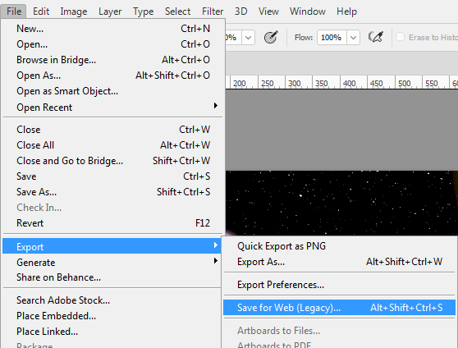
4. In the upper-right hand corner of the Save for Web window, make sure the options match those in the image below…  
   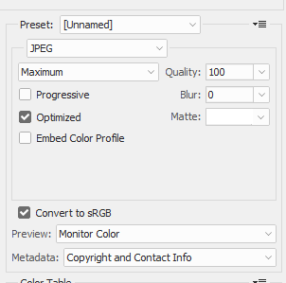
5. Click **Save**
6. Go to the **Photoshop** folder within your student folder and make the File name your **ID number** (yes, the same number you use to log in to the computer – by naming your file with your ID number no one will know who created which scene so the voting can be anonymous)
7. Click **Save**